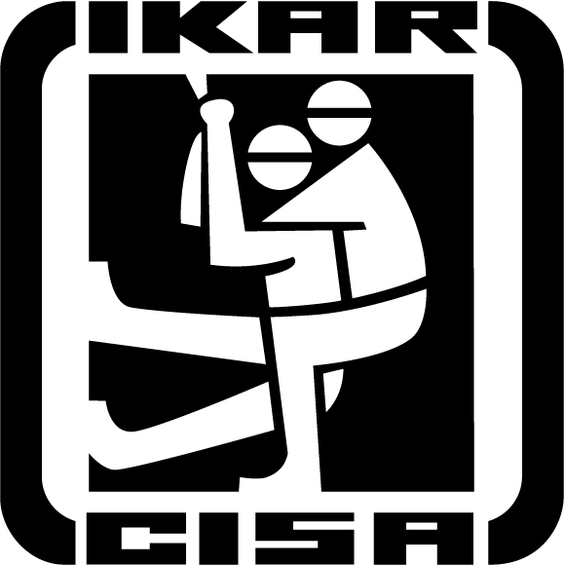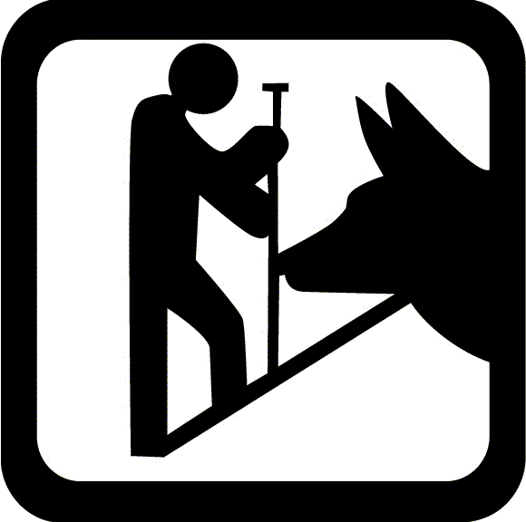

Report

ICAR, ARC and CAA Field Session in Revelstoke, March 21-25, 2011

Monday, March 21

Welcome, Introductions and Orientation at Best Western Inn, Revelstoke, BC, Canada

Tuesday, March 22

Lectures on Revelstoke Mountain Resort

Morning Sessions:

Ian Tomm, Executive Director CAA and CAC, Canada - Opening Remarks

Hans-Juerg Etter, Switzerland - Fatality Trends Around the World, a brief look at long term
fatality trends in ICAR member countries.
The trends are looking as in most big winter tourism country the avalanche fatalities are raising in the last few years.

Aaron Beardmore, Parks Canada - SAR for Parks Canada; Organisation, Education and Rescue Actions.

Per-Olov Wikberg, Sweden, Swedish National Mountain Safety Council - How to Identify
and Reach Different Target Groups in Accident Prevention in Sweden.

Frederic Jarry, France - Trend of Avalanche Fatalities in France and Avalanche Education Problems and Future solutions in France.

Manuel Genswein, Switzerland - Deep Burial Extrication.

Albert Lunde, Norway - Avalanche Programs in Norway.

Per-Olov Wikberg, Sweden, Swedish National Mountain Safety Council - Avalanche
Education and Forecasting in Sweden.

Dusan Polajnar, Slovenia - Avalanche Prevention in Slovenia.

Afternoon Field Practice

- Deep Burial Extrication - Manuel Genswein
- Companion Rescue Education for Heliskiers - Derek, Selkirk Tangiers
- Avalanche Rescue Dogs, Searching with dogs and discussion - CARDA Canadian
Avalanche Dog Association
- Pieps - a new tool and discussion - Norm Winter and Zusana Isert.

Daily Debrief.

Evening Sessions:

Ian Tomm - Search and Rescue Services in BC

Buck Corrigan, Revelstoke, BC, Chief of the Revelstoke Search & Rescue Team
- SAR around Revelstoke
- Meeting with the SAR team

Tour of CAA/CAC Offices
Cam Campbell, CAC - Presentation on Avalanche Forecasting in Canada.

March 23 and 24

One day: Helicopter-Assisted Ski Touring,
Guides Meeting/Briefing with the topics:
- Weather, weather forecast
- Avalanche observation
- Stability degree (1 - 5)
- Opinion of the attending guides
- Summary of the avalanche danger
- Evaluation of each run (green: good; yellow: uncertain; red: closed; black closed for an indefinite time.

Field Activity:
- Presented by Applied Snow and Avalanche Research (ASARC) with University of Calgary.
- Snow profiles and Stability Tests used in Canada
- A Review of Professional and Recreational approaches

One day: Snowmobile, riding lesson and avalanche education for Snowmobilers, Snowmobile practice, travel to Boulder Hut and Turbo Hill area where the largest snow mobile avalanche accident happened in March 2010 (more than 60 snowmobilers involved and 2 snowmobilers were killed). Explanation and discussion about.

Indoor:

- Safety talk, Avalanche Danger Prevention and Education for Snowmobilers.

- Phil Hein, President of the CAA Board - Education levels in Canada (3); modular composition for professionals. Included below is a brief description of each of the Canadian Avalanche Operations courses; level 1 through 3.
Avalanche Operations Level 1
This course is the first professional level training course for persons who are seeking employment with avalanche risk management operations. Participants must be advanced skiers or splitboarders and should have considerable backcountry travel experience commensurate with industry standards. The Level 1 course is an essential prerequisite course to many other industry-training programs including guiding.
This intensive 7 to 8 day technical training course is comprised of approximately 40% theory & classroom work and 60% practical application & field work. See Sample Course Schedule under "Related Links" for an example of an average day.

Program Goals
- State the formation & nature of avalanches & the hazards involved
- Apply personal & group safety measures & perform companion rescue
- Recognize avalanche terrain
- Participate in organized search & rescue
- Describe significant properties of the mountain snowpack
- Collect & record weather, snowpack and avalanche occurrence data
- State the factors that are applied in snow stability evaluation
- State elements of operational risk management and decision making
Avalanche Operations Level 2
The Level 2 Program is divided into three modules. Module 1 focuses on decision making, advanced snow science concepts and operational risk management principles in a four-day, theory-based classroom environment. Modules 2 and 3 are field-based programs that involve the application of Module 1 principles into real-life operational decision making and risk management. Module 2 is a three and ½-day field course in an evaluation-free setting. Module 3 is a seven-day course where students’ skills and competency in both technical knowledge and practical application of Level 2 concepts is evaluated. Successful completion of Module 3 results in a Level 2 certification by the CAA.
Program Goals
- collect & evaluate detailed weather, snowpack & avalanche data
- travel safely in avalanche terrain
- evaluate & forecast snow stability for different geographic areas
- manage personal wellness & performance
- evaluate terrain & its interaction with the mountain snowpack
- develop & apply effective communication and teamwork skills
- evaluate & forecast avalanche hazard
- develop concepts of risk management for the workplace
Avalanche Operations Level 3
This 5-day classroom-based course is a requirement for CAA qualifications for both Avalanche Forecasters and Avalanche Planners
Program Goals
- The principles of avalanche hazard and risk
- Avalanche hazard evidence and data stream
- Heuristics and bias in avalanche hazard forecasting
- Avalanche risk assessment, management and control
- The role of uncertainty and confidence in forecasting
- Communicating avalanche hazard and risk
- The avalanche hazard analysis, assessment & forecasting process
____________________________
Conference Wrap-up; Meet the Sponsors.
Conclusion:

It was an interesting event and everybody could learn a lot.
It is a starter for the ICAR ARC to invest more time in avalanche prevention and education.
We should continue in a part of the Field Practice Day from ICAR ARC in Are next fall.

The topic will be: Prevention and Education for professionals and recreationals in the different countries (including a diagram structure)

All of the presentations are available through the following link:

https://avalanche.box.net/shared/7clsgdda0v

Thanks to
- the CAA staff for organizing this event. They did a perfect job in organizing and accomplishment.
- all volunteers for their big help
- the sponsors who helped make this CAA and ICAR ARC Field Session possible.

Special thanks go to

- Ian Tomm, Executive Director CAA and CAC
- Kristin Anthony-Malone, Operations Manager CAA
- Audrey Defant, Client Services CAA

for their perfect, great and excellent work.

Hans-Juerg Etter
ICAR, Chairman Avalanche Rescue Commission (ARC)

Davos, April, 2011

Participants

Beardmore Aaron Canada
Cardinale Dean USA
Dietrich Beat Switzerland
Dietrich Jolande Switzerland
Eriksson Anders Sweden
Etter Hans-Juerg Switzerland
Genswein Manuel Switzerland
Hein Phil Canada
Jarry Frederic, France
Kjellstroem Alf, Sweden
Lindberg Staffan, Sweden
Lunde Albert, Norway
Mark Bill Canada
Nilsson Matts Sweden
Nord Leif Sweden
Oshiro Kazue Japan
Polajnar Dusan Slovenia
Volontar Klemen Slovenia
Wikberg Per-Olov Sweden

and many part time attendee.

Links to videos:

Day one
http://www.wbrescue.org/blog/ari-theodore/2011-ikar-conference-spring-field-session-revelstoke-bc

Day two
http://www.youtube.com/watch?v=9S7q_wzfefU&feature=email

Day three
http://www.youtube.com/watch?v=22JqG2E-3DI&feature=email

Thanks to Dean Cardinale for the videos.

Links to photos:

http://www.wikbergs.com/IKAR_Revelstoke_day1

http://www.wikbergs.com/IKAR_Revelstoke_day2_snowmobile/

http://www.wikbergs.com/IKAR_revelstoke_day3_heliskiing

http://www.wikbergs.com/ParcsKanada_Banff/

Thanks to Per-Olov Wikberg

